**C Coursework**

**Engduino Application**

The display code is written using Processing 3. The input is light sensor and button data from the Engduino. It displays a graph of light intensity against time updated in real time.

The button is used to change the “ Backlight mode ” which essentially changes the background colour up or down the white to black spectrum. There are 4 different modes (Auto, Bright, Medium, Dark) which allow the user to choose whichever her/she deems appropriate at the current light levels.

Below are screenshots of the display in Auto and Bright mode.

**Set Up**

Upload Arduino.ino code into Engduino. Press run in Processing 3 to run display program. Press Engduino button to toggle between modes.

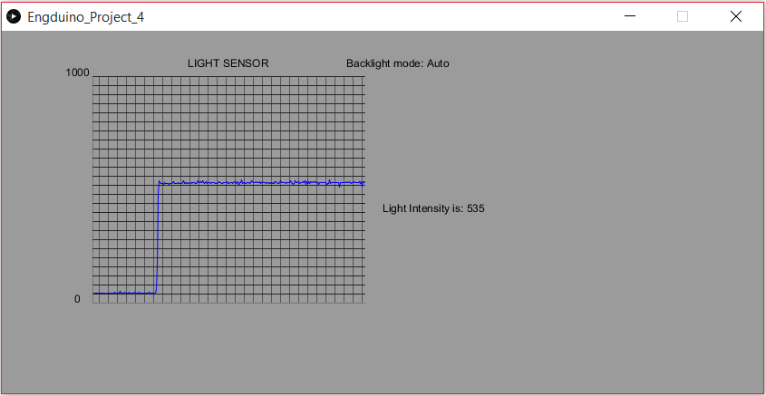

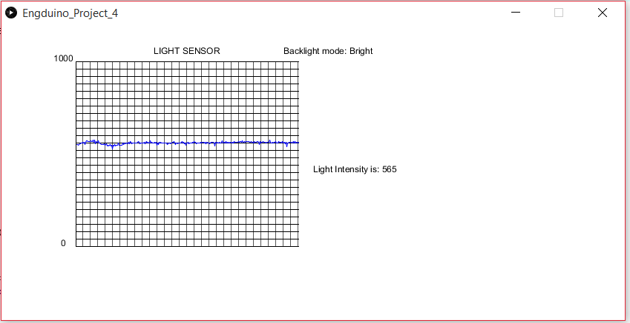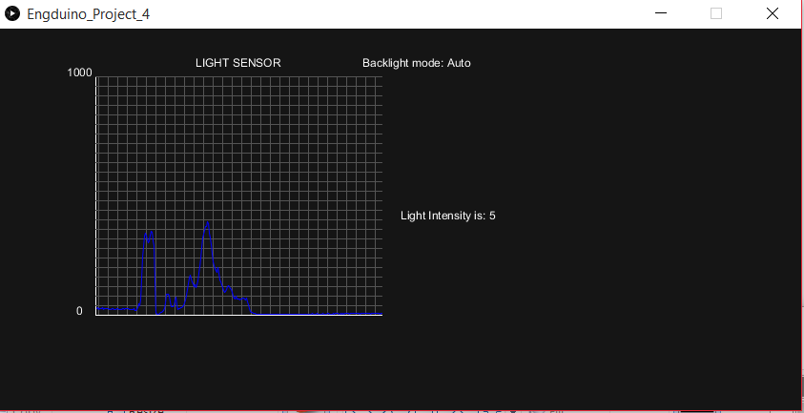

**OpenSCAD**

My OpenSCAD Engduino stand is designed to have the functionality of storing large number of Engduinos in a tower format (stacking) efficiently, and without damaging the Engduinos.

It consists of 3 parts : base, USB case and hinge pole.

The Engduino is put into the USB case and the case is slit into the socket on the base. Then the hinge pole is put through.

If desired to erect the Engduino, the USB case should be pushed all the way in until it snap-locks. When desired for storage, the USB case is unlocked and laid flat. Legs of other Engduino stands are slipped into the drain.